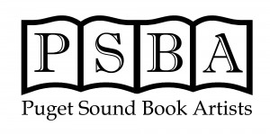
Thank you for supporting our primary fundraising event with your donation, described below:
The Puget Sound Book Artists (https://pugetsoundbookartists.wildapricot.org) is a non-profit 501(c) (3) organization. Donations to the PSBA Washington are deductible to the extent allowed by law.
Please fill out a separate form for each item you are donating. You may complete the form by hand, but it would be preferable if you could save it as a Word document on your computer, type in the information, and email the completed form to Jamie Spaine (jspaine@pugetsound.edu)
Donor Name:
Address:
City: State: Zip Code:
Phone: Email:

Would you like to receive an acknowledgment letter for your tax records?
Yes _____ No _____

If you are offering a service, use of your property, hosting an event, etc. are there any restrictions on scheduling or availability that a bidder should know?
The default will be “must be used by December 31, 2019.

If you will be providing a certificate, advertising board or other physical representation for use at the Auction, please attach or describe:

It is very helpful to receive your auction items in advance. You can let us know any time that you plan to donate item(s) by contacting Jamie Spaine (jspaine@pugetsound.edu) and we will arrange to get it from you prior to the event.

Title of Item:
Estimated Value of the Item: $__________
Detailed description for Bid Sheet:

